Name: | ___________________________________________________ |  |  |  | Date: ___________
 | Subject - Year 8 Mathematics  Investigation 2, 2013  Topic – Factors  Take home component
Date out: |  | Week ____ Date | Date Due: | Week ____ Date
Take home component weighting: |  | 4 Marks | In-class component weighting: | 5% of the year.
AIM: In this assessment, you will be investigating area and perimeter for simple and compound shapes.
There are two parts to this assessment:
Item | Purpose | Marks available
Take-Home | To test your knowledge of square numbers, prime numbers, factors, prime factors | 2 marks
In-Class | To test your knowledge of square numbers, prime numbers, factors, prime factors | 5 % of year

This Take-Home part is to be completed at home and you have one week to complete it. You will not be permitted to do this part in class. If you need help there are after-school maths classes where you can obtain help.

NOTE: You will need to use your Take-Home part in the In-Class.

THE FACTOR MACHINE

SQUARE NUMBERS

- A square number is the result (product) you get when you multiply a number by itself.
eg 16 is a square number because 4 x 4 = 16
49 is a square number because 7 x 7 = 49
100 is a square number because 10 x 10 = 100

Circle which of the following numbers are square numbers:

1, 12, 25, 35, 64, 72, 90, 121

FACTORS

- A factor is a number that can be divided into another number exactly (with no ‘remainders’).
eg 1, 2, 3, 6 are all factors of 6 because 6 ÷ 1 = 6
6 ÷ 2 = 3
6 ÷ 3 = 2
6 ÷ 6 = 1

4 is not a factor of 6 because 6 ÷ 4 = 1^{2/}₆ or 1^{1/}_{3 .} In other words, two is left over after you divide
6 by 4.

- A method to ensure that you have all the factors of a number is to start dividing by 1 then work your
way up to divide by 2 then by 3 then by four etc. Once you start getting the same factors repeating, you
have found all of the factors.
Eg 12 ÷ 1 = 12 So factors are 1 and 12
These are the smallest and biggest factors and all other factors will occur between them.
12 ÷ 2 = 6 So factors are 2 and 6
12 ÷ 3 = 4 So factors are 3 and 4
12 ÷ 5 Does not go exactly so is not a factor
- 4 = 3 We already have these so once we are repeating, we have them all.

TASK 1:
Write the factors of the following numbers next to each number. The first one has been done for you:

Number | Factors | Number of Factors
30 | 1, 2, 3, 5, 6, 10, 15, 30 | 8
12
26
50
100

- A machine in Number Land was invented to hold all positive factors. (that is, not negative numbers). This Factor Machine correctly stores numbers according to how many positive factors a number has.
For example:

9 has 1, 3, and 9 as factors.

Therefore it is placed in column 3 because it has 3 factors.

13 has 1, and 13 as factors.

Therefore it is placed in column 2 because it has 2 factors.

18 has 1, 2, 3, 6, 9, and 18 as factors.

Therefore it is placed in column 6 because it has 6 factors.

TASK 2

- Use the table below to write the factors of each number next to it. The first 20 have been done for you.

Number | Factors | Number of Factors
1 | 1 | 1
2 | 1, 2 | 2
3 | 1, 3 | 3
4 | 1, 2, 4 | 3
5 | 1, 5, | 2
6 | 1, 2, 3, 6 | 4
7 | 1, 7 | 2
8 | 1, 2, 4, 8 | 4
9 | 1, 3, 9 | 3
10 | 1, 2, 5, 10 | 4
11 | 1, 11 | 2
12 | 1, 2, 3, 4, 6, 12 | 6
13 | 1, 13 | 2
14 | 1, 2, 7, 14 | 4
15 | 1, 3, 5, 15 | 4
16 | 1, 2, 4, 8, 16 | 5
17 | 1, 17 | 2
18 | 1, 2,, 3, 6, 9, 18 | 6
19 | 1, 19 | 2
20 | 1, 2, 4, 5, 10, 20 | 6
21
22
23
24
25
26
27
28
29
30
31
32
33
34
35
36
37
38
39
40
41
42
43
44
45
46
47
48
49
50
53
59
61
64
67
71
73
79
81
83
89
97
100

TASK 3

Place the numbers given in the table above correctly into the factor machine according to how many
factors each number has. The first 20 numbers have been done for you. Be very careful when counting
factors; it is very easy to miss a factor. As a guide, when you finish:

- Column 2 should have 25 numbers
- Column 3 should have 4 numbers
- Column 4 should have 15 numbers
- Column 5 should have 2 numbers
- Column 6 should have 8 numbers
- Column 7 should have 1 number
- Column 8 should have 4 numbers
- Column 9 should have 2 numbers
- Column 10 should have one number

TASK 4 The Factor Machine

 | 19
 | 17
 | 13
 | 11 |  | 15
 | 7 |  | 14
 | 5 |  | 10 |  | 20
 | 3 | 9 | 8 |  | 18
1 | 2 | 4 | 6 | 16 | 12

1 2 3 4 5 6 7 8 9 10

No of Factors

PRIME NUMBERS

A prime number has only two factors: 1 and itself. In other words, it can only be divided by 1 and itself.

eg 29 is a prime number because it can only be divided by 1 and 29
41 is a prime number because it can only be divided by 1 and 41
17 is a prime number because it can only be divided by 1 and 17

NOTE: 1 is not a prime number as it has only one factor: itself. It is called a special number.

TASK 5

Circle the prime numbers found in the list of numbers below:

2, 4, 5, 6, 9, 12, 15, 19, 31, 37, 39

PRIME FACTORS

Prime factors are factors that are prime numbers.
eg the prime factors of 15 are: 3 and 5 3 x 5 = 15
the prime factors of 20 are 2 and 5 2 x 2 x 5 = 20 (or 2² x 5 = 20)

FACTOR TREES OR FACTOR LADDERS
To work out the prime factors, you can use a factor tree like the one below where you find two factors
then find the prime factors of each of these numbers.
eg Factor Trees

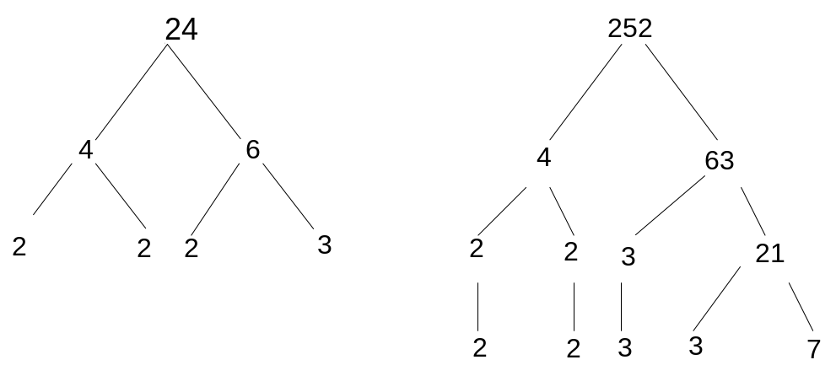

24 = 2 x 2 x 2 x 3 252 = 2 x 2 x 3 x 3 x 7

= 2³ x 3 = 2² x 3² x 7

eg Factor Ladders

With factor ladders, you divide the number by the smallest prime factor you can then
keep dividing the answer until you get to 1.
eg
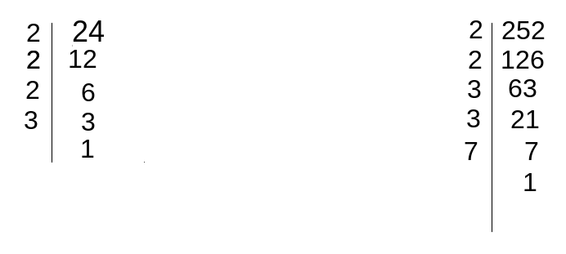
24 = 2 x 2 x 2 x 3 252 = 2 x 2 x 3 x 3 x 7

= 2³ x 3 = 2² x 3² x 7

TASK 6

Use a factor tree or factor ladder to find the prime factors of:

- 42 b) 63

End of Take Home Section

Name: | ___________________________________________________ |  |  |  |  | Date: ___________
 | Subject - Year 8 Mathematics  Investigation 2, 2013  Topic – Factors  In class component |  |  |  |  | 25  = %
Total Time: | 60 minutes
Reading Time: | 5 minutes
Working Time: | 55 minutes
Weighting: | 5% of the year.
Equipment: | Scientific Calculator
Date out: |  | Week 1 |  | Date Due:
Take home component weighting: |  | 2 Marks |  | In-class component weighting: | 5% of the year.
AIM: In this assessment, you will be investigating area and perimeter for simple and composite shapes.
There are two parts to this assessment:
Item | Purpose | Marks available
Take-Home | To expand your knowledge of square numbers, prime numbers, factors, prime factors | 2 marks
In-Class | To test your knowledge of square numbers, prime numbers, factors, prime factors | 25
 | Total | 25

This In-Class part is to be completed in class and you have one session to complete it. It will be run under exam conditions, in the same manner as exams and assessments in future years, in order that you become accustomed to them.

You are permitted the following:
- Take home section of investigation
- A scientific calculator
- Normal writing instruments
You will not be permitted to borrow equipment from others during the assessment.

- (1 mark)

What is a square number?

- (3 marks: ½ each)

List all the square numbers less than 40

- (4 marks: 2, 2)

Use either a factor tree or factor ladder to find the prime factors of:

- 25 b) 36

- (2 marks: 1, 1)

Use your results from the factor machine in your take home section to answer the following questions:

- If more numbers are added to the factor machine, will there be any further additions to column 1? If so, which numbers do you predict they will be?

- Justify your answer for part a) above.

- (1 mark)

What kind of numbers are found in column 2?

- (6 marks: 4, 2 )

- What columns are square numbers found in?

- Why do you think that these numbers will all have odd numbers of factors?

- (2 marks)

What is different about the square numbers found in column 3?

- (2 marks:1, 1)

Look at the first number that appears in columns 2, 3, 5, and 7. Now try to predict the first number that
will appear in columns 11 and 13 if we had extended the factor machine that far. Write your predicted
numbers below:

- (2 marks)

Given a number, can you find out how many factors it will have without writing them all down and counting them? (Hint: using prime factorisation)
12 = 2² x 3¹ and it has 6 factors
64 = 2⁶ and it has 7 factors
30 = 2¹ x 3¹ x 5¹ and it has 8 factors

End of Investigation

